How to purchase ingredients for recipes from Hogashop using the Calcmenu web.
- Choose a recipe from the list on the Calcmenu Web.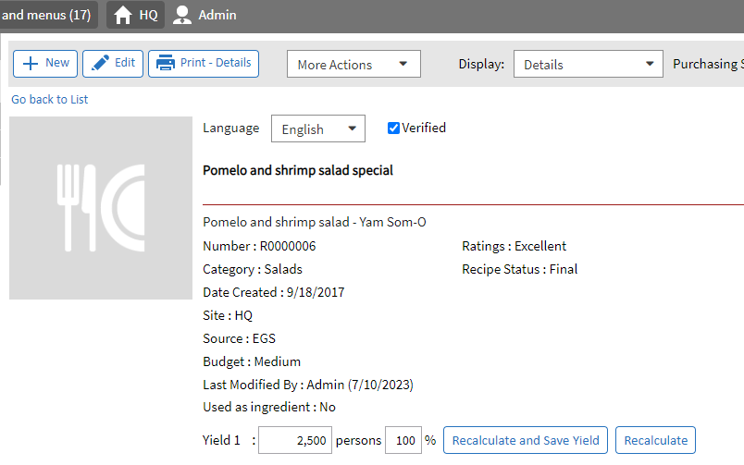

- Click more action>Print/Export>Add to shopping List

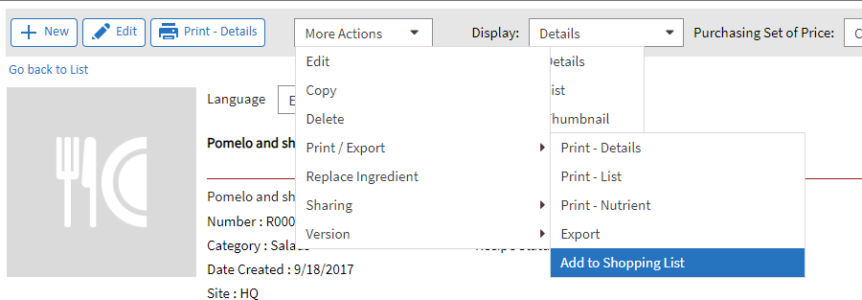

- When you click on a recipe from the list on Calcmenu Web, the ingredients for that recipe will be shown. Click the 'Add to Hogashop' button, and a popup will appear.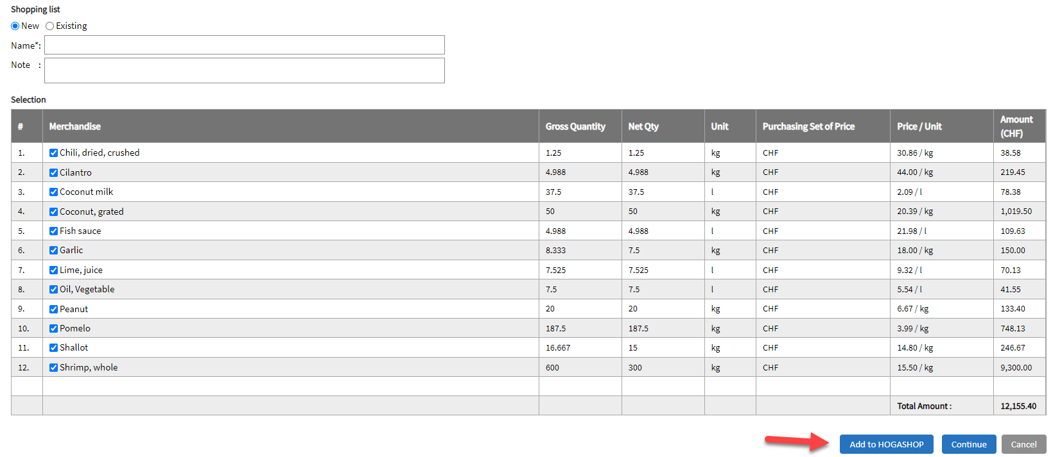
- The popup will display a list of ingredients or products for the recipe sourced exclusively from Hogashop. Any ingredients for the recipe that are not available from Hogashop will be excluded from the list.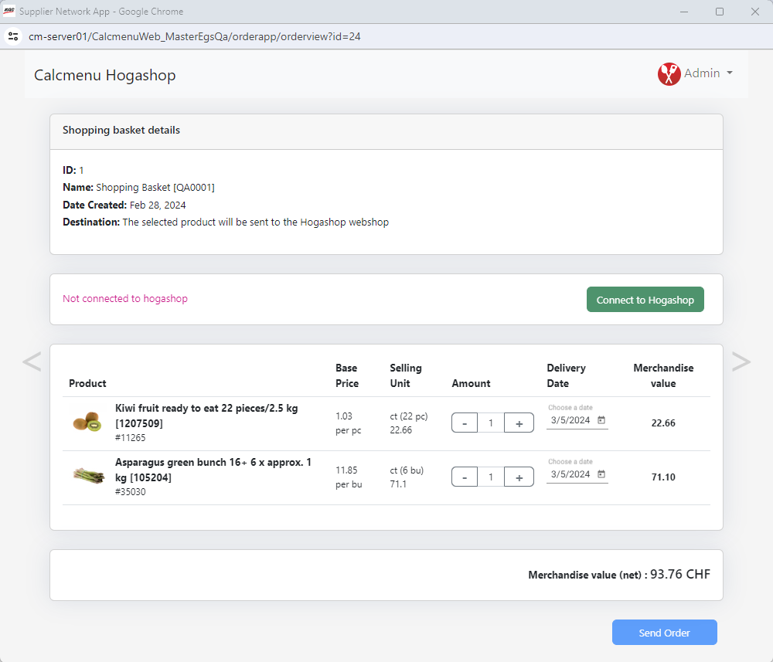

- To place an order, the user needs to first connect their Hogashop account by clicking the 'Connect to Hogashop' button.

- A login pop-up will appear, prompting the user to enter their Hogashop username and password. Upon successful login, the user will gain access to the option to grant permission for connecting
to Hogashop.
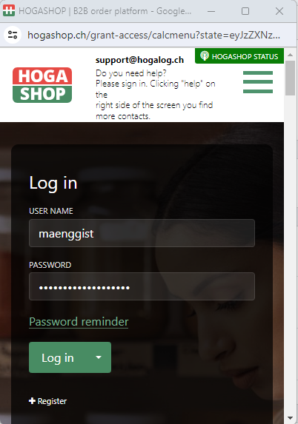

- Following successful login, a message will appear from Calcmenu requesting access to customer data. To proceed with connecting Calcmenu to the Hogashop client account, click the 'Allow Access' button.
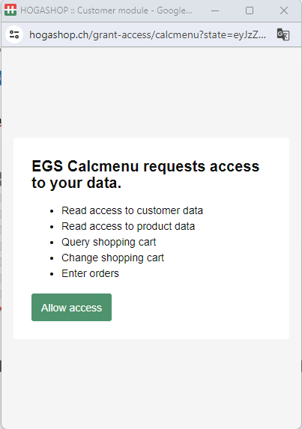

- After confirming, you'll notice in the order window that the customer account is now connected to Calcmenu, displaying customer information, and the 'Send Order' button is now enabled.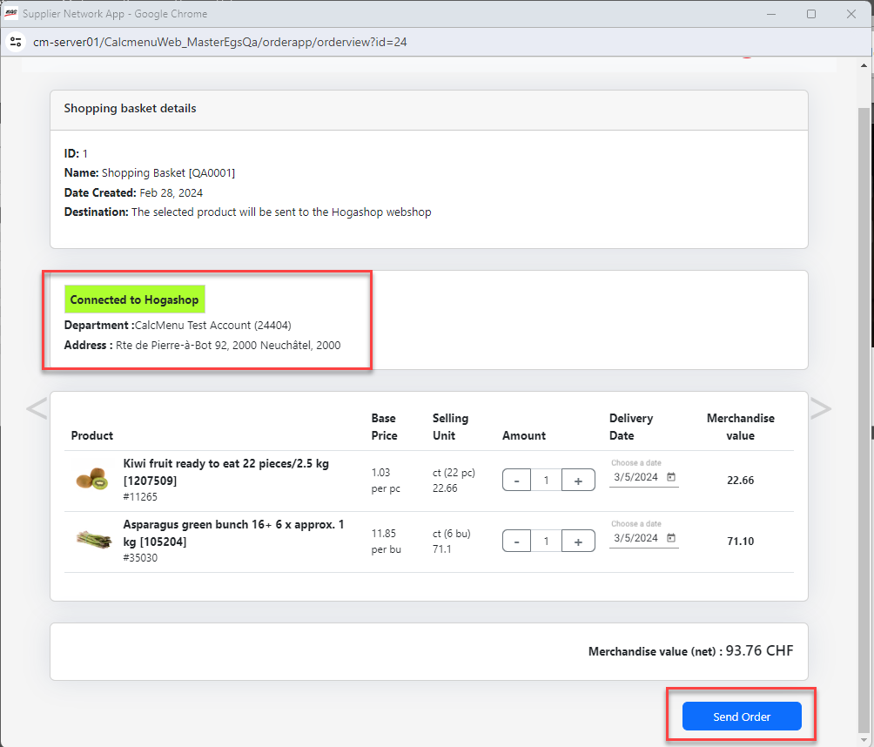

- Upon clicking the 'Send Order' button, a confirmation message will appear indicating that proceeding will delete the products in the current basket. Choose 'Yes' to proceed with sending the order, or 'No' to cancel.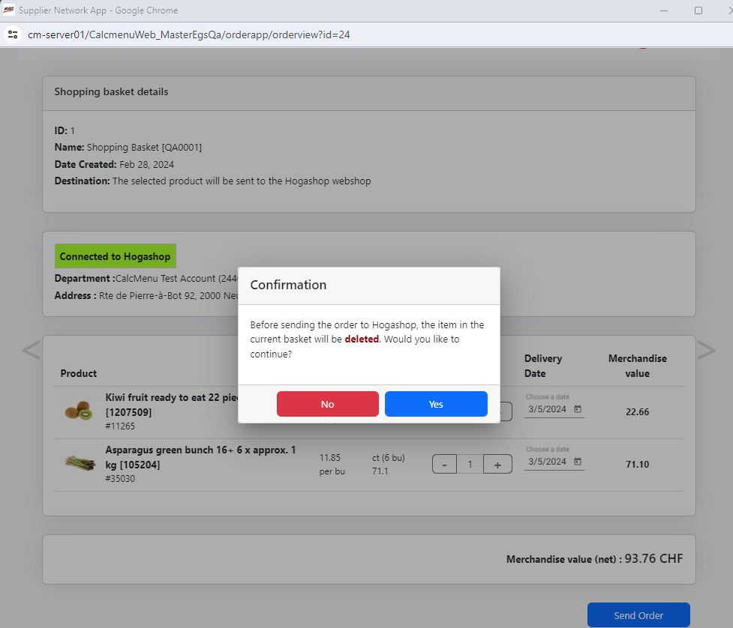

- After proceeding, a message will appear indicating whether the order was successfully sent or not.

For example: 'Failed since the user has no rights to send order